Kubernetes Task - 1

Setup minikube at your local and explore creating namespaces (Go through official documentation).

1. Install kubectl (PowerShell)
1.1.Go to a safe folder
# cd C:\Users\$env:USERNAME\Downloads
# Invoke-WebRequest -Uri "https://dl.k8s.io/release/v1.29.0/bin/windows/amd64/kubectl.exe" -OutFile kubectl.exe
# dir kubectl.exe
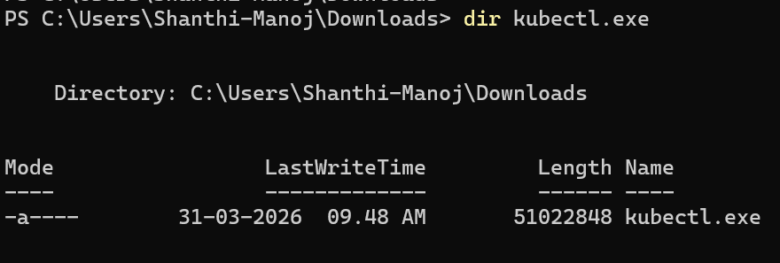
# mkdir C:\k8s
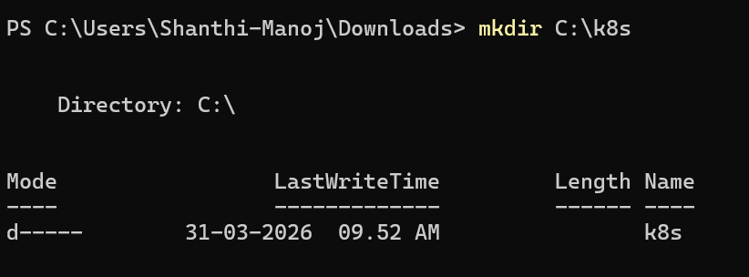
# move kubectl.exe C:\k8s\
# $env:Path += ";C:\k8s"
# kubectl version –client
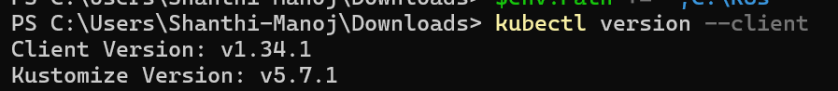

2. Install Minikube
Download:
# curl.exe -LO https://storage.googleapis.com/minikube/releases/latest/minikube-windows-amd64.exe
Rename:
# Rename-Item minikube-windows-amd64.exe minikube.exe
Move:
# move minikube.exe C:\k8s\
Verify:
# minikube version
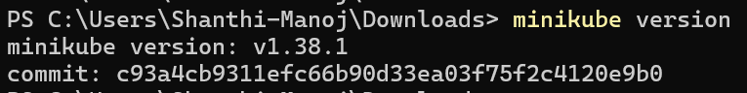
3. Start Minikube
# minikube start --driver=docker
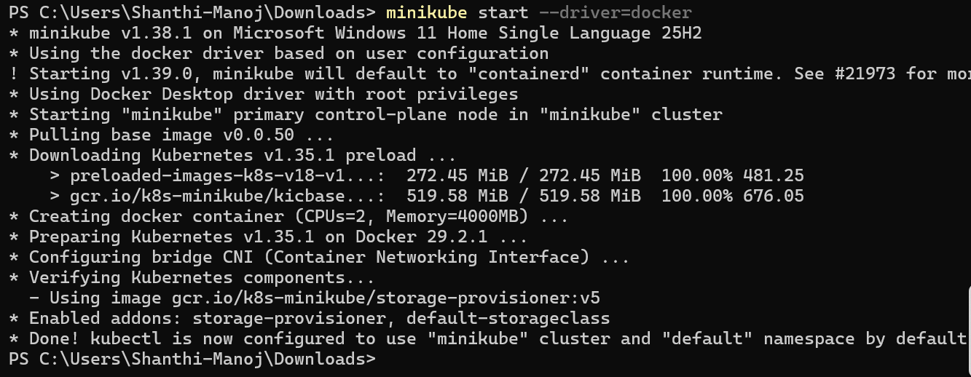
# minikube status
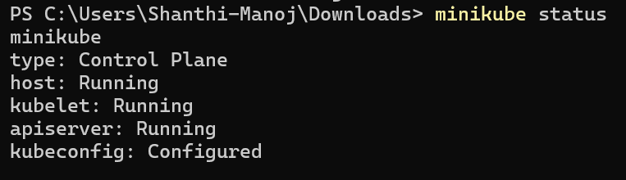
4. Basic Kubernetes Commands
# kubectl cluster-info
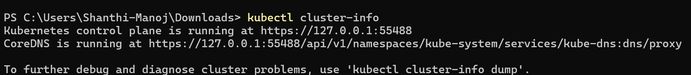
# kubectl get nodes
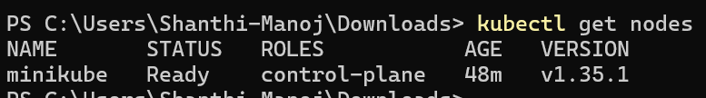
5. Namespace Commands
5.1. Check namespaces
# kubectl get namespaces
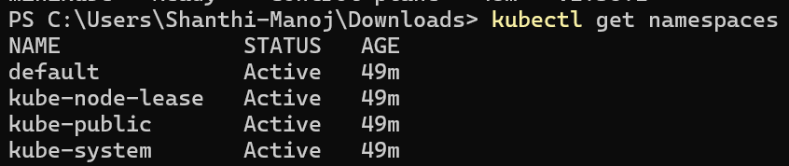
5.2. Create namespace
# kubectl create namespace myfirst-namespace
5.3. Verify
# kubectl get namespaces
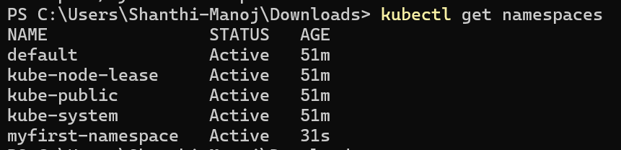
5.4. Create pod inside namespace
# kubectl run nginx-pod --image=nginx -n myfirst-namespace
5.5. Check pods
# kubectl get pods -n myfirst-namespace
5.6. Describe namespace
# kubectl describe namespace my-namespace
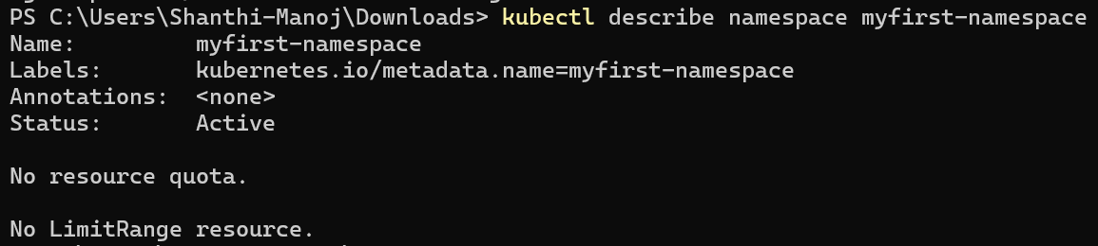
5.7. Set default namespace
# kubectl config set-context --current --namespace=myfirst-namespace
5.8. Delete pod
# kubectl delete pod nginx-pod -n myfirst-namespace
5.9. Delete namespace
# kubectl delete namespace myfirst-namespace

